Topic of the lesson: Equivalent Fractions
Overall goal for this lesson: Students will learn about how to identify, generate, and
reduce equivalent fractions
Specific objectives for this lesson:
1. Students will understand what the term ‘equivalent’ means.
2. Students will understand how two fractions can be equivalent even though their numerators/denominators differ.
3. Students will be able to recognize if two fractions are equivalent.
4. Students will be able to produce equivalent fractions
5. Students will be able to reduce fractions.
State Standards or Common Core State Standards that this lesson will meet:
CCSS.Math.Content.4.NF.A.1 Explain why a fraction a/b is equivalent to a fraction (n × a)/(n × b) by using visual fraction models, with attention to how the number and size of the parts differ even though the two fractions themselves are the same size. Use this principle to recognize and generate equivalent fractions.
This lesson also builds upon the previous Common Core State Standards from the beginning of the year:
CCSS.Math.Content.4.OA.A.1 Interpret a multiplication equation as a comparison, e.g., interpret 35 = 5 × 7 as a statement that 35 is 5 times as many as 7 and 7 times as many as 5. Represent verbal statements of multiplicative comparisons as multiplication equations.
CCSS.Math.Content.4.OA.B.4 Find all factor pairs for a whole number in the range 1–100. Recognize that a whole number is a multiple of each of its factors. Determine whether a given whole number in the range 1–100 is a multiple of a given one-digit number. Determine whether a given whole number in the range 1–100 is prime or composite.
Students: 25 students.
Five diagnosed with learning disabilities.
About one-quarter read one to two grade levels below their grade placement (6).
About one-third of has difficulty writing. Their writing is disorganized and often is peppered with spelling and other errors (8).
About half do not like to write (12).
Most have difficulty memorizing and/or recalling basic facts.
Many struggle with mathematics concepts and mathematics problem solving
LIST THE AGE OR GRADE OF YOUR STUDENTS HERE: Fourth Grade, Second Quarter, Ages 9-10
Prerequisite Skills and Knowledge:
1. Basic multiplication and division facts 1-10
2. Basic understanding/background knowledge of fractional parts of a whole (how to count fractional parts)
3. Able to define/recognize the term ‘numerator’ and ‘denominator’
4. Basic understanding/background knowledge of place value (½ is greater than ¼)
Lesson materials:
- Whiteboard, whiteboard marker, eraser
- Elmo projector/laptop (access to the following website: http://www.ronblond.com/MathGlossary/)
- Giant magnetic fraction bars manipulative for whiteboard:
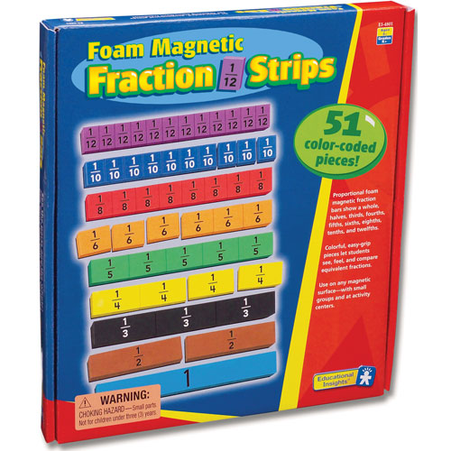

- “Equivalent Fraction Notes” (“Skeleton”/outlined notes for whole group instruction)
- 25 Fraction Strips worksheets:
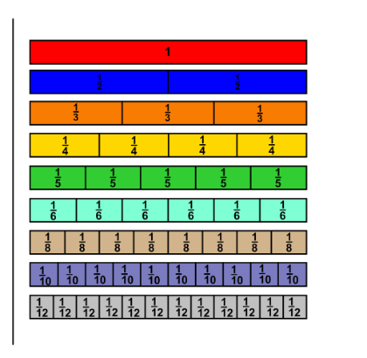
- 125 pieces of construction paper (for flip book)
- Stapler
- 8 pairs of scissors
- 8 glue sticks
- 4 Computers (for access to the following website: http://www.freewebs.com/weddell/equivalent.swf)
- Fraction hopscotch (painters tape, ball to roll)
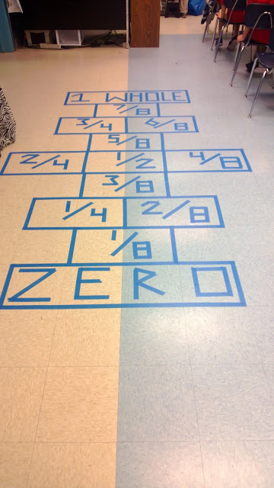 (found on the following website: http://imperishablybeautiful.blogspot.com/2013/01/teaching-fraction-hopscotch.html)
- 25 laminated math facts (listing 1-10 multiplication/division facts)
- “Equivalent Fraction” Practice worksheet
- 25 Note Cards (for exit tickets)
Lesson Opening: Activating Background Knowledge/Introduction (5 minutes)
- Introduce lesson topic and define the term ‘equivalent’
  - I will start off the lesson asking the students what the term “equal” meant. Once students volunteer/define the word accurately I will have them think of things in math which were equal to one another. We would brainstorm as a group numbers which were equal to one another. I will visually model on the board how 3=3, 5=5 therefore, ½ must equal ½ (while talking them through their thinking). While writing down these fractions on the board I will review the terms denominator/numerator with the students. I will proceed with writing the word “equivalent” on the board and ask the students what they think this term means. Have one student look up the term on (http://www.ronblond.com/MathGlossary/) and have it project onto the screen. I will then come to the conclusion with my students what the term means while thinking aloud to model. I will then have the students repeat this term back to me verbally as a whole group three times (in a sing song tone to help it stick). I will then call on several individuals to repeat back to me what ‘equivalent’ means.
  - Tell the students we will be learning today how to make two fractions equivalent/ equal in value to one another. By the end of today they will be able to list two different fractions that are equal to one another!
Forms of UDL:
- Clarify vocabulary & symbols (reviewed terms/introduced the term ‘equivalent’)
- Guide information processing, visualization, and manipulation
Lesson Activities: (45 Minutes)
Whole Group Instruction (10 Minutes)
- Pass out “Skeleton”/outlined notes (The notes are partially typed in so the students will follow along but not become discouraged with the writing task/taking notes).
- Pass out “laminated math facts” for the students who are struggling with their math facts.
- Have students fill in definition of ‘equivalent’ independently
  - This will allow me to see who is having a hard time grasping the term. Once the students finish writing I will write on the board “equal in value” for them to copy down.
- Model how ½ is equivalent to 2/4 feedback
  - I will have magnetic rectangle fraction visuals on the board. I will have one rectangle which represented ½ and one which represented ¼. I will give a word problem to my students which they can relate to. For example “pretend you & your friend split a candy bar. How much of the candy bar would each of you eat?” (While modeling with the fractional parts). Then I will explain to the students “the candy bar is cut into four parts/pieces (fourths). How many parts/pieces would you and your friend eat?” while explaining this scenario to the students I will be writing the fractional parts down under each fraction. I will then brainstorm with the students how to get from 1/2 to 2/4 (numerator: 1 to 2 denominator: 2 to 4). I will model on the board how to multiply the numerator and denominator by the same number (always equaling “one”: http://media-cacheec6.pinterest.com/originals/b8/6b/0a/b86b0aad0d46c2d7b695c3bf4a3d4bf6.jpg)
- Have students fill in guided notes on the steps of finding an equivalent fraction (while I write it on board to model)
- Complete 2 more equivalent fraction examples with whole group
UDL:
- Activate/supply background knowledge (candy bar example)
- Maximize transfer and generalization (guided notes)
- Guide information processing, visualization, and manipulation
Group/Center Instruction (35 Minutes)
- I will begin by taking 5 minutes to explain each center. Each center will last 10 minutes. I will then split the students into 3 groups of 8. I will pair the students based on ability level (low, medium, high). The ‘low group’ will start at group A. The ‘medium group’ will start at group B (teacher time). The ‘high group’ will start at group C. The centers consist of:
  - Group A (targeted toward visual/tactile learners)
    - Students will then make a flip book to have a manipulative they can use in future homework assignments/fraction lessons. I will pass out 5 sheets of paper and a printed fraction strip for each student. If there are any students with fine motor concerns, I will have the fraction strips precut. I will also have an example of the finished product for a model.
    - http://www.makingbooks.com/stepbook.pdf
    - http://www.math-drills.com/fractions/fraction_strips_color_labeled.html
  - Group B (targeted toward auditory learners/students who require additional support/repetition/challenging and higher level thinking):
    - Introduce how to ‘reduce’ fractions by dividing numbers. I will go through the steps by using the “skeleton”/outlined notes.
    - For those who begin to understand how to reduce fractions, I will provide practice problems. I will also challenge their thinking by providing mixed numbers or fractions where they have to reduce their answer.
    - For those who are still having misconceptions I will break the steps down and continue to review the steps with the students.
  - Group C (targeted toward kinesthetic/visual learners):
    - Students get to pick which game they would like to play in groups:
      - Play hopscotch (http://imperishablybeautiful.blogspot.com/2013/01/teaching-fraction-hopscotch.html)
      - 4 computers set up- students will play this game in groups of two http://www.freewebs.com/weddell/equivalent.swf

Forms of UDL:
- Support planning and strategy development (“think aloud” strategy)
- Foster collaboration and community (center/group work)
- Build fluencies with graduated levels of support for practice and performance (differentiating instruction for all learners)
- Offer alternatives for auditory information
- Illustrate though multiple media
Conclusion (10 Minutes)

- Bring students back together
- Pass out “equivalent fraction” worksheet. I will review the directions with the whole group and have them highlight when they have to make an ‘equivalent’ fraction (multiply) or ‘reduce’ a fraction (divide). I will also have the students write multiply and/or divide next to each section so they know which skill they will be applying (since they are being introduced to new content). Students will have the opportunity to work independently or with a partner. During this time they can use their flip book to solve the problems. Students who struggle with math facts will also have laminated multiplication/division fats to use as a reference. I will walk around during this time providing additional assistance to those who are struggling.

Forms of UDL:
- Using multiple tools for construction and composition (math reference sheet, flip book)
- Optimize individual choice and autonomy (getting to pick between hopscotch or computer game, picking to work individually or with a partner, monitor their own behavior so they will continue to have these privileges)
Assessment:
I will be informally assessing my students’ understanding during whole and small group instruction. I will provide feedback and take notes on students who are struggling to master the material. I will carry a notepad around and mark off students who still require additional teacher time.

I will also have an ‘exit ticket’ at the end of a lesson which will have students:
- Reduce ‘16/20’
- Write an equivalent fraction to ‘2/3’
  - ***Both of these problems would be written on the board. I will be sure to read both aloud and underline the terms reduce/equivalent for the students who need these accommodations.

Forms of UDL:
- Enhance capacity for monitoring progress (feedback throughout lesson to guide self-monitoring and reflection)

